Doppler effect
The Doppler effect, named after physicist Christian Doppler who proposed it in 1842, is the change in frequency of a wave for an observer moving relative to the source of the wave. It is commonly heard when a vehicle sounding a siren or horn approaches, passes, and recedes from an observer. The received frequency is higher (compared to the emitted frequency) during the approach, it is identical at the instant of passing by, and it is lower during the recession (as it moves away)
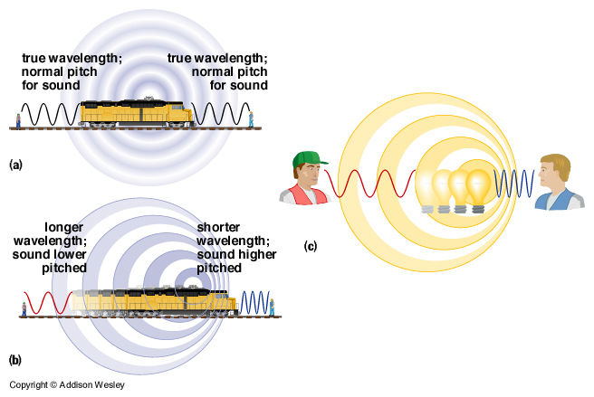

Light and the Doppler effect
The Doppler effect for electromagnetic waves such as light is of great use in Astronomy and results in either a so-called “redshift”, as things move away from the observer or a blue shift as they move towards the observer. This colour change is used to help investigate the movement of galaxies and their stars. Since most galaxies are moving away from each other this is supporting evidence for the Big Bang theory.


